1.

**Using Map Reduce:**

Command:

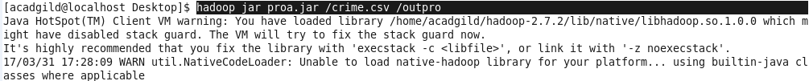

**Driver:**

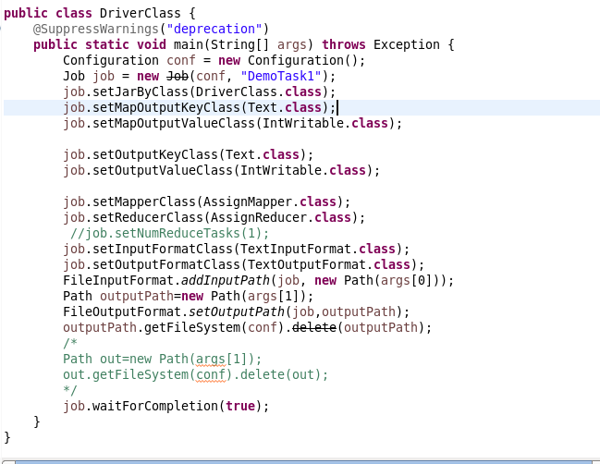

**Mapper:**

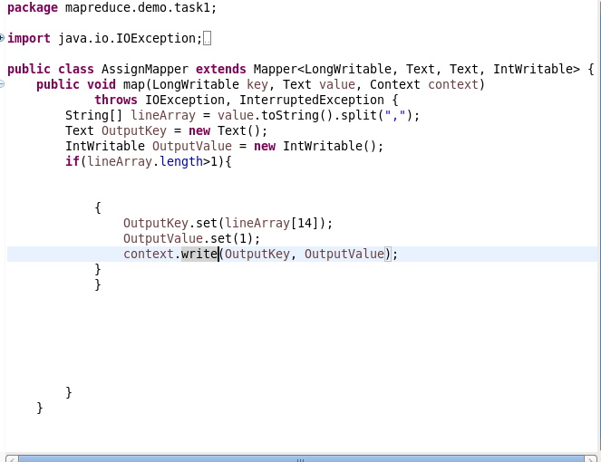

**Reducer:**

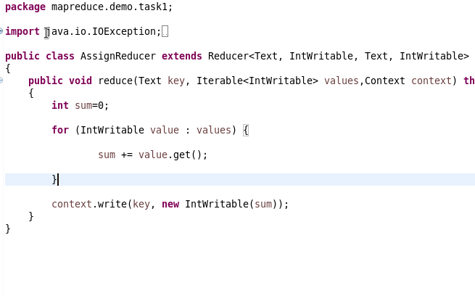

**Output:**

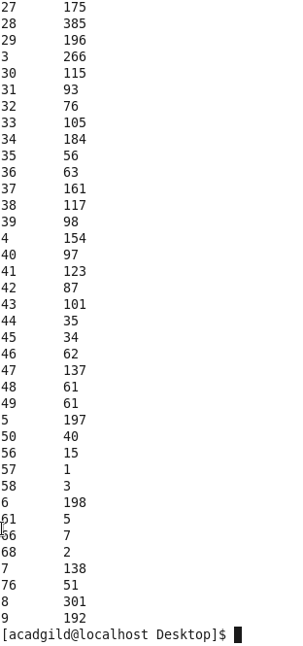

**Using Pig:**

**Command:**

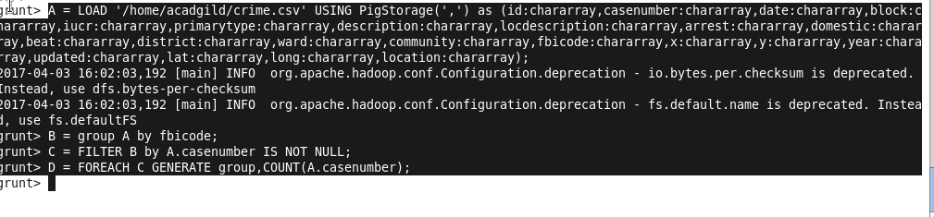

**Output:**

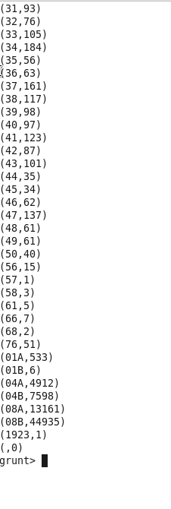

**2.**

**Using Map Reduce**:

Command:

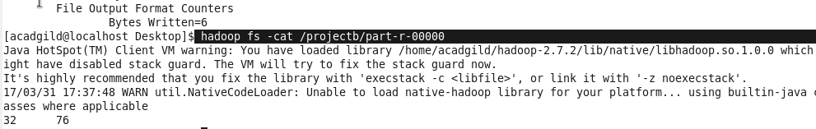

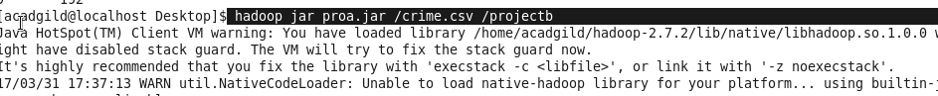

**Driver:**



**Mapper:**

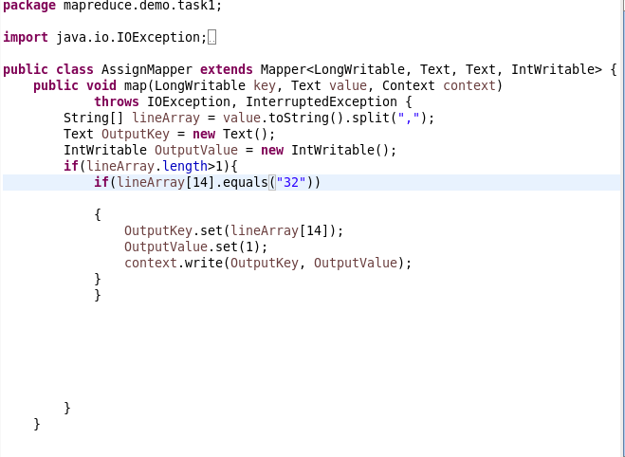

**Reducer:**



**Output:**

C:\Users\613000\Desktop\projectboutput.PNG

**Using Pig:**

Commands:

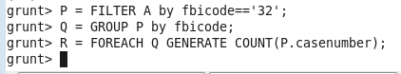

**Output:**

**C:\Users\613000\Desktop\project2pigout.PNG**

**3.**

**Using Map Reduce:**

Command:

C:\Users\613000\Desktop\projectccmd.PNG

**Driver:**

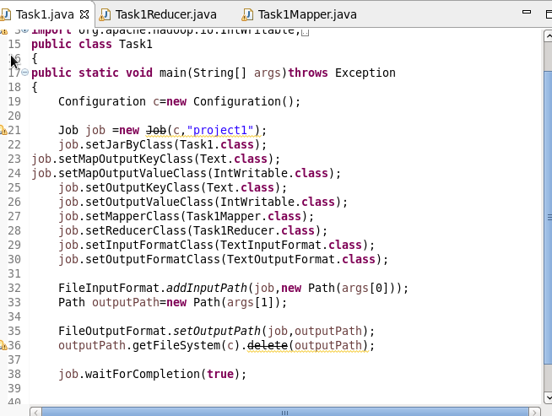

**Mapper:**

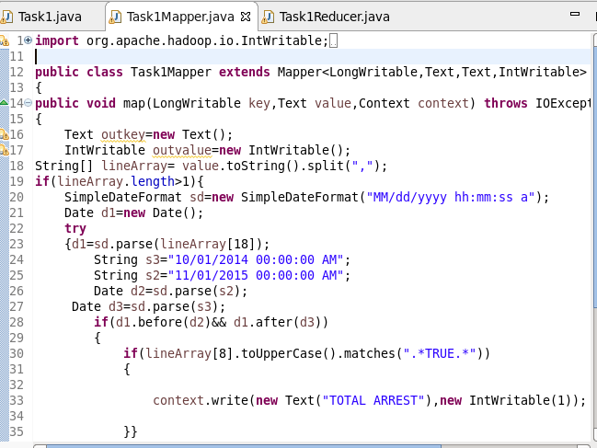

**Reducer:**

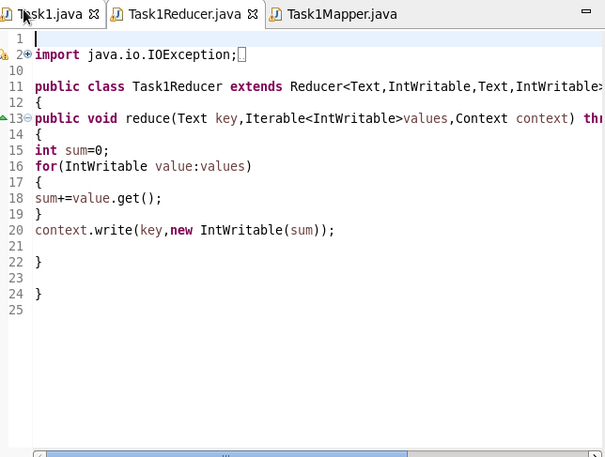

**Output:**

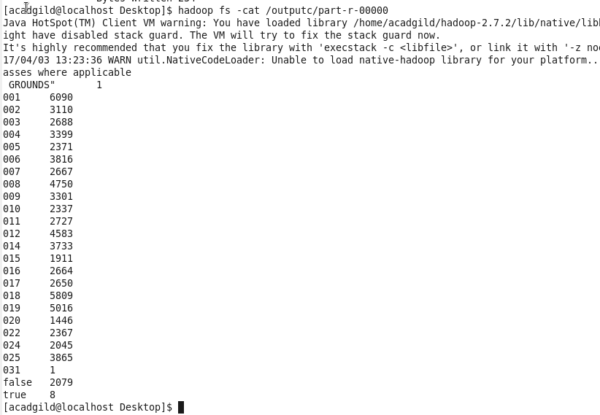

**Using Pig:**

Commands:

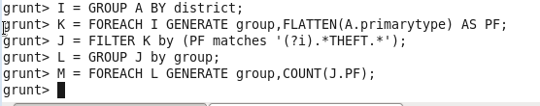

**Output:**

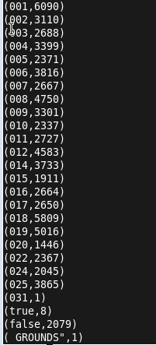

**4.**

**Using Map Reduce:**

Command:

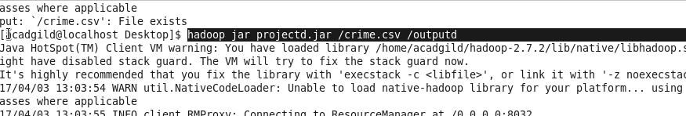

**Driver:**

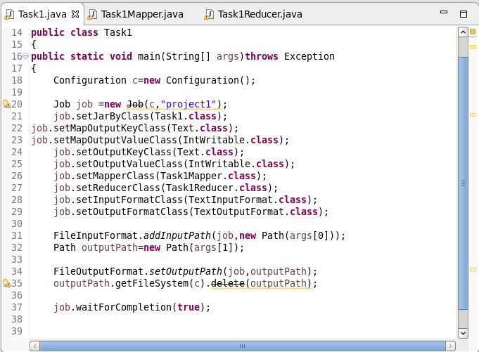

**Mapper:**



**Reducer:**

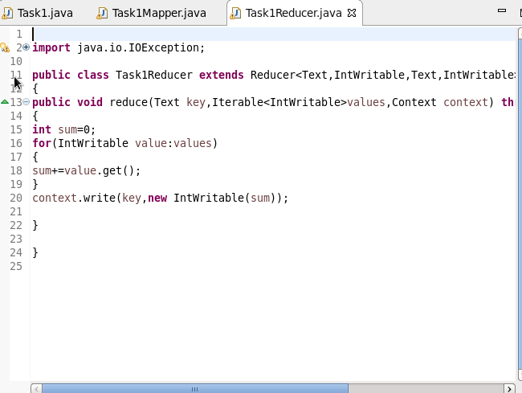

**Output:**

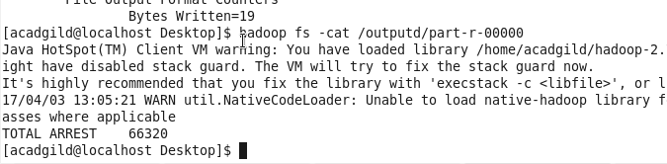

**Using Pig:**

Commands:

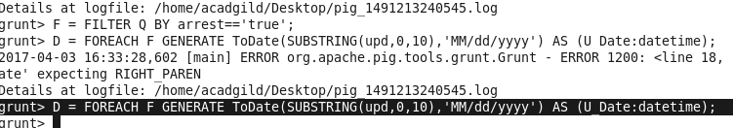

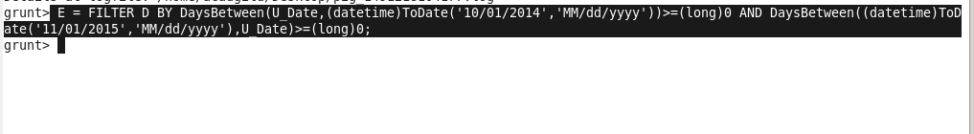

**Output:**

